Contents

1. Main Screen (With Header and Navigation Bar): - 2

2. Main Screen with “Our Medicines” Menu open & scrolling background: - 2

3. Main Screen with “Health Care” Menu open & scrolling background: - 3

4. Navigation Bar is visible in the Top of the Webpage: - 3

5. Size of the Product Item increases when hovered screen 1: - 4

6. Size of the Product Item increases when hovered screen 2: - 4

7. Footer: - 5

8. On Click of Lab Test the “Lab_test” page opens: - 5

9. Image is in the same place while scrolling: - 6

10. System Alerts if any Test Type is not selected: - 6

11. System Alerts if the Date and Time is not selected: - 7

12. System Alerts if the time is less than 2 hours from now: - 7

13. Success Alert Message: - 8

14. Mandatory Field Alerts: - 8

a. Screen 1 (Full Name): - 8

b. Screen 2 (Contact Number): - 9

c. Screen 3 (Email Id): - 9

d. Screen 4 (House No.): - 10

e. Screen 5 (Street): - 10

f. Screen 6 (Area): - 11

g. Screen 7 (District): - 11

h. Screen 8 (Test Type): - 12

i. Screen 9 (Date & Time): - 12

j. Screen 10 (Time to be 2 hours from now): - 13

k. Screen 11 (Success): - 13

## Main Screen (With Header and Navigation Bar): -

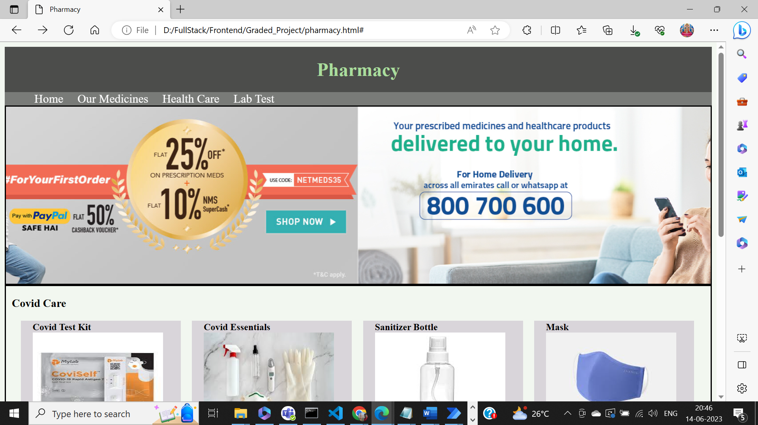

## Main Screen with “Our Medicines” Menu open & scrolling background: -

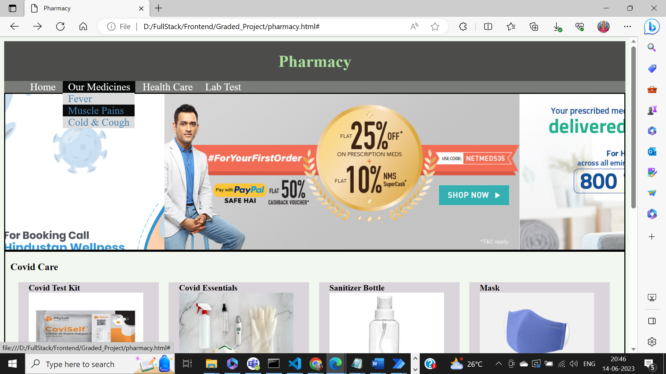

## Main Screen with “Health Care” Menu open & scrolling background: -

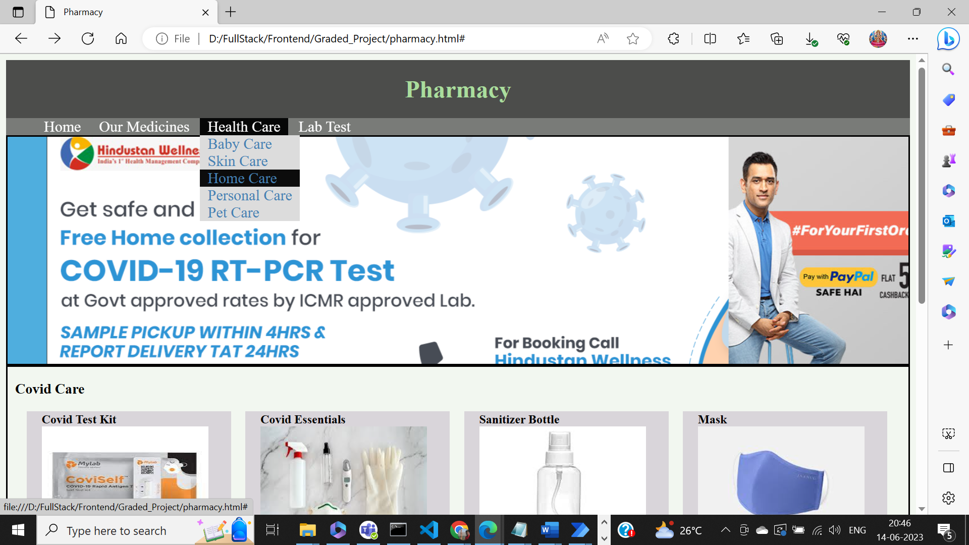

## Navigation Bar is visible in the Top of the Webpage: -

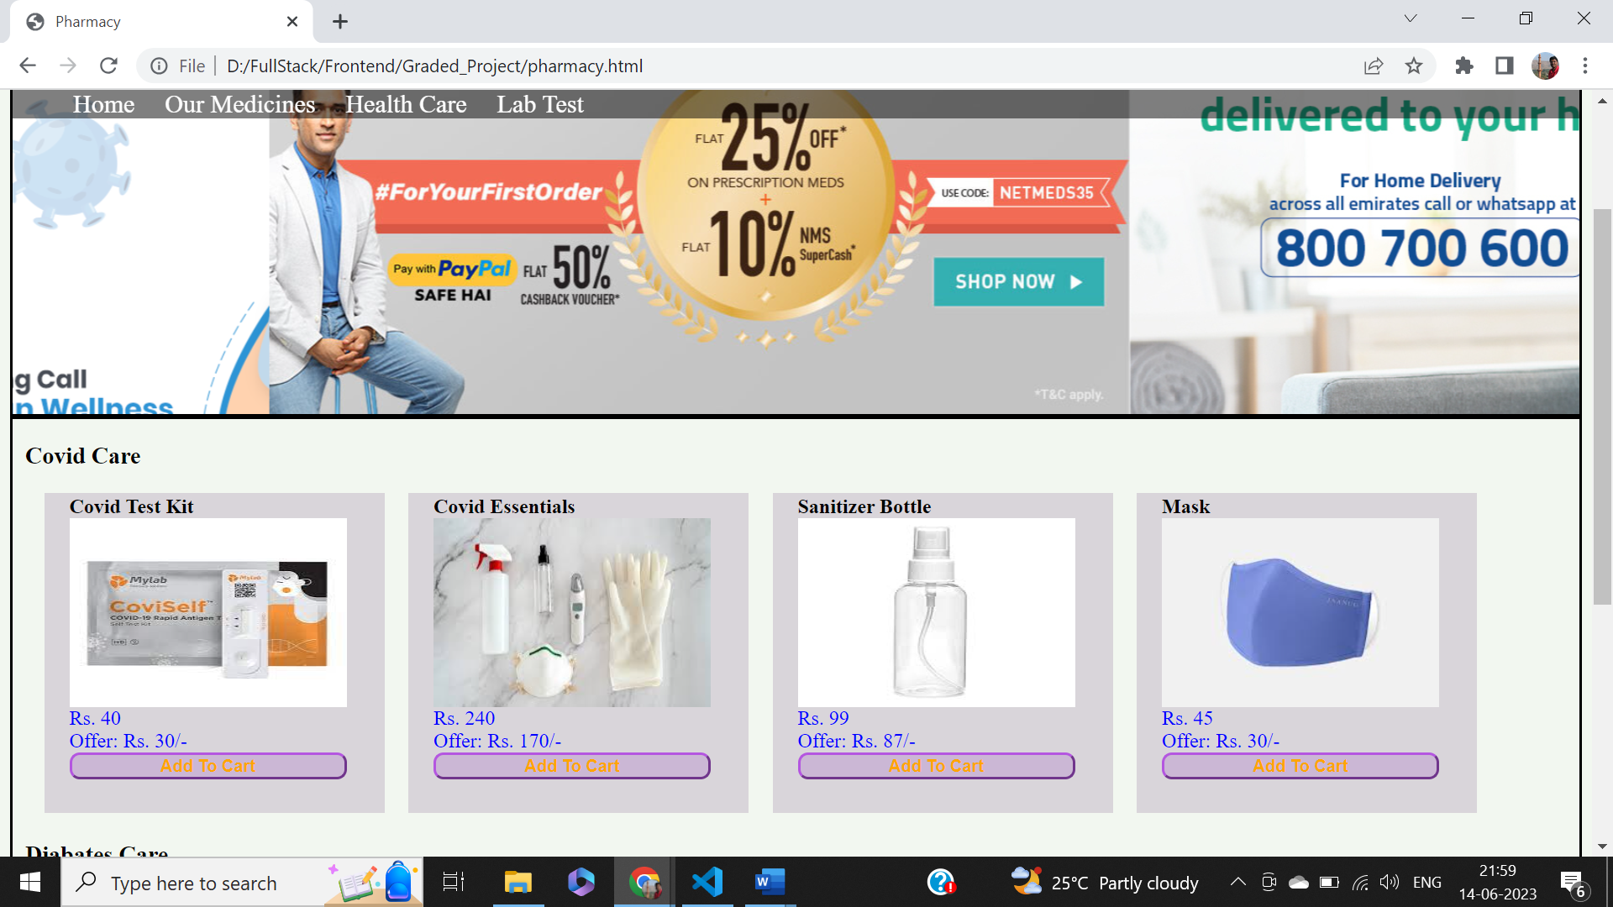

## Size of the Product Item increases when hovered screen 1: -

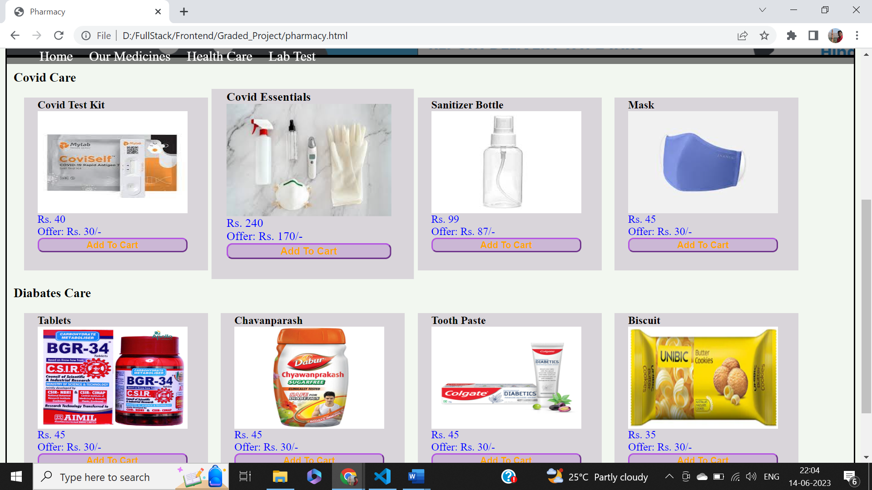

## Size of the Product Item increases when hovered screen 2: -

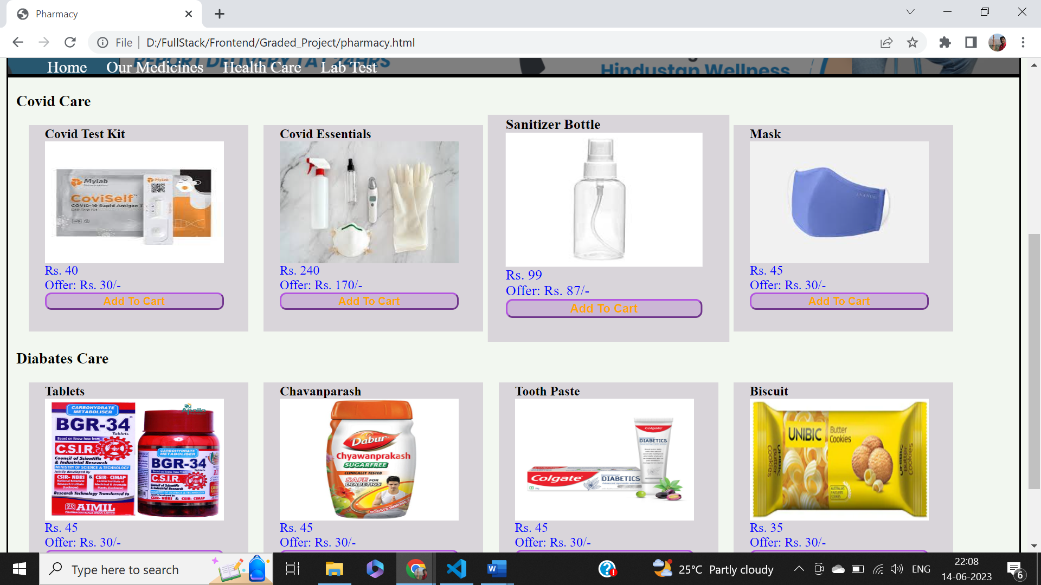

## Footer: -

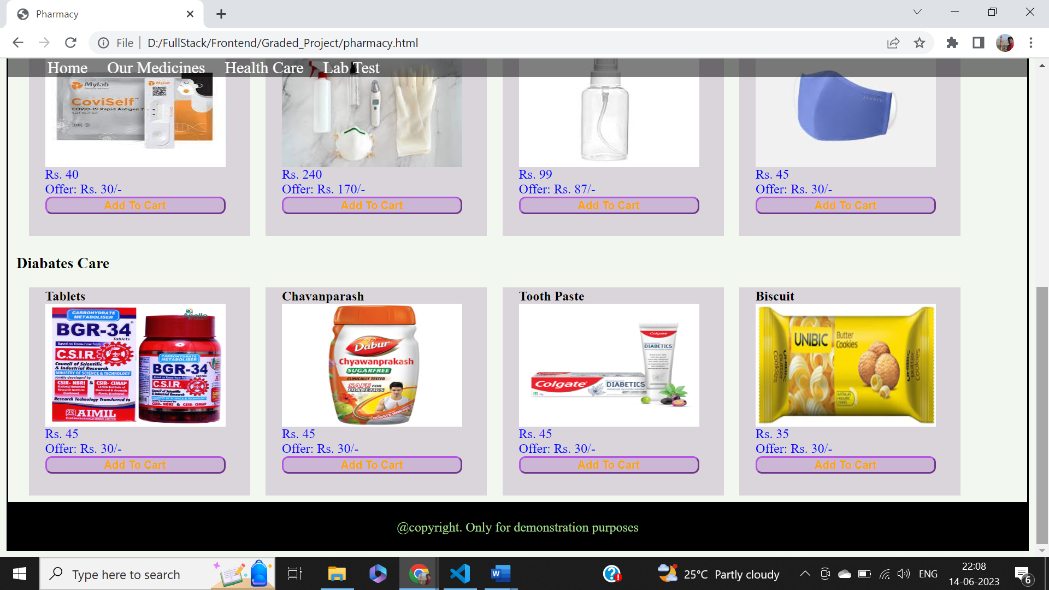

## On Click of Lab Test the “Lab_test” page opens: -

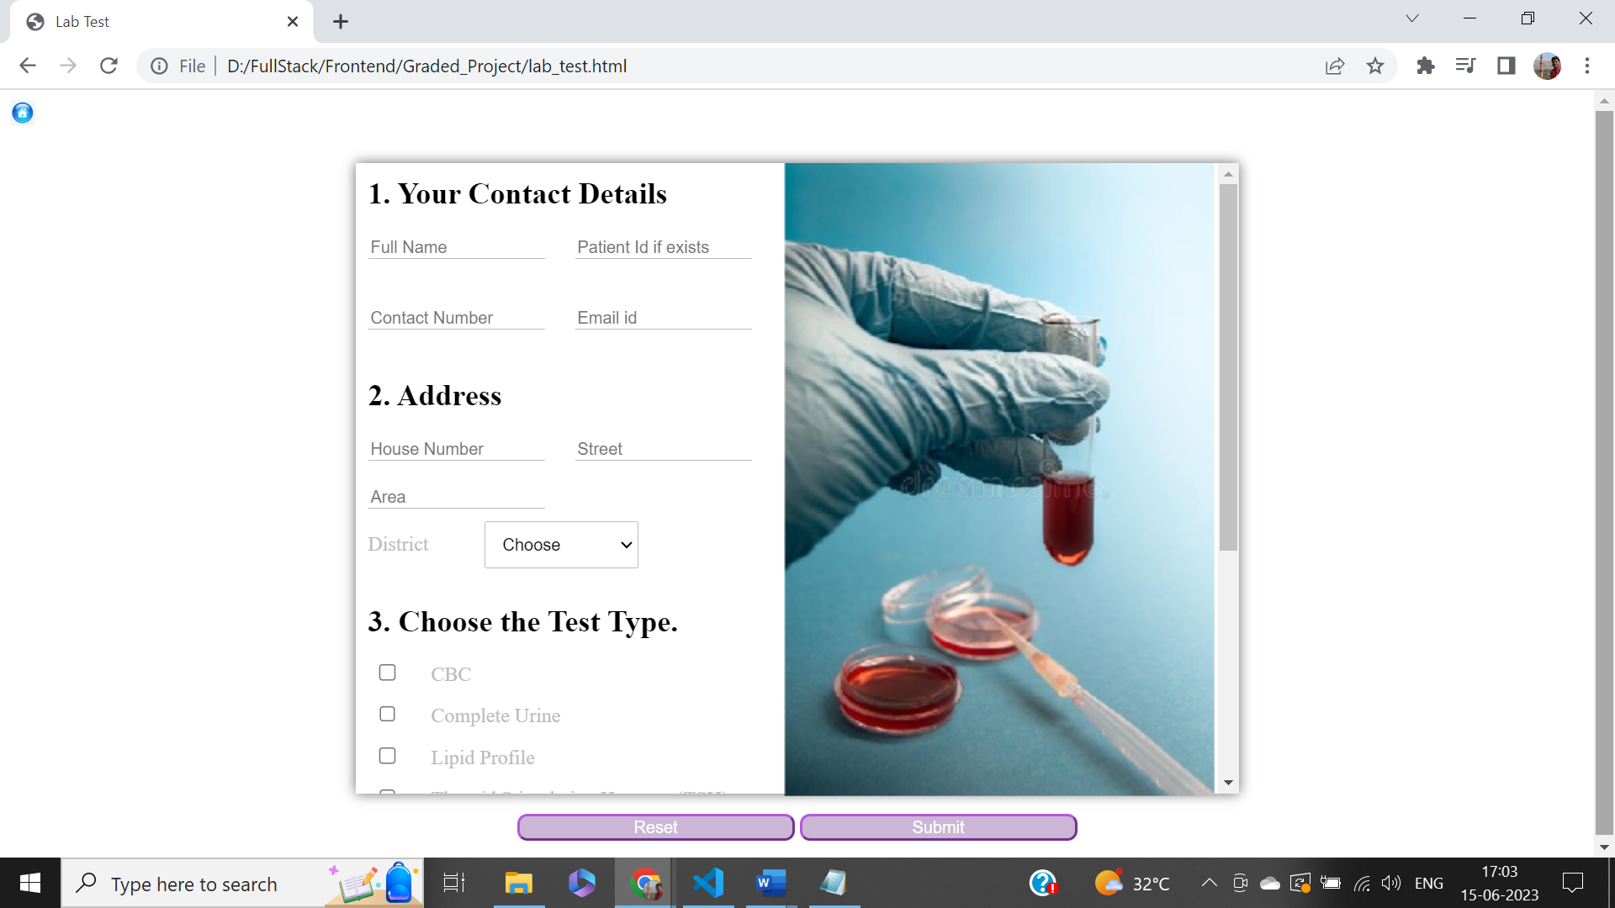

## Image is in the same place while scrolling: -

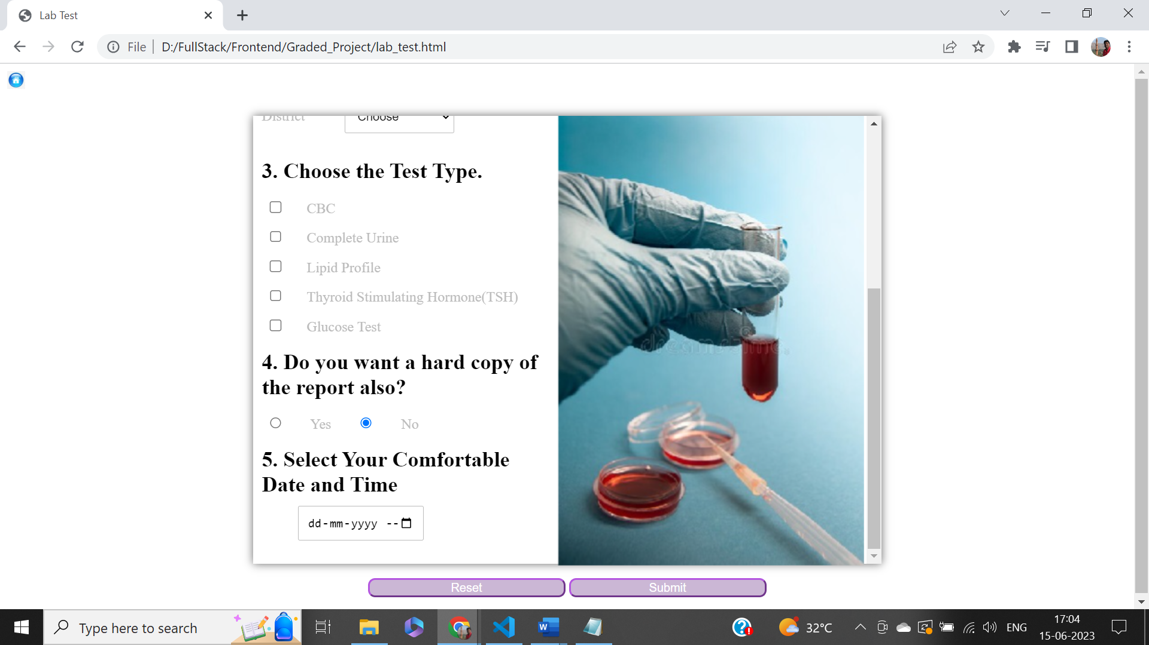

## System Alerts if any Test Type is not selected: -

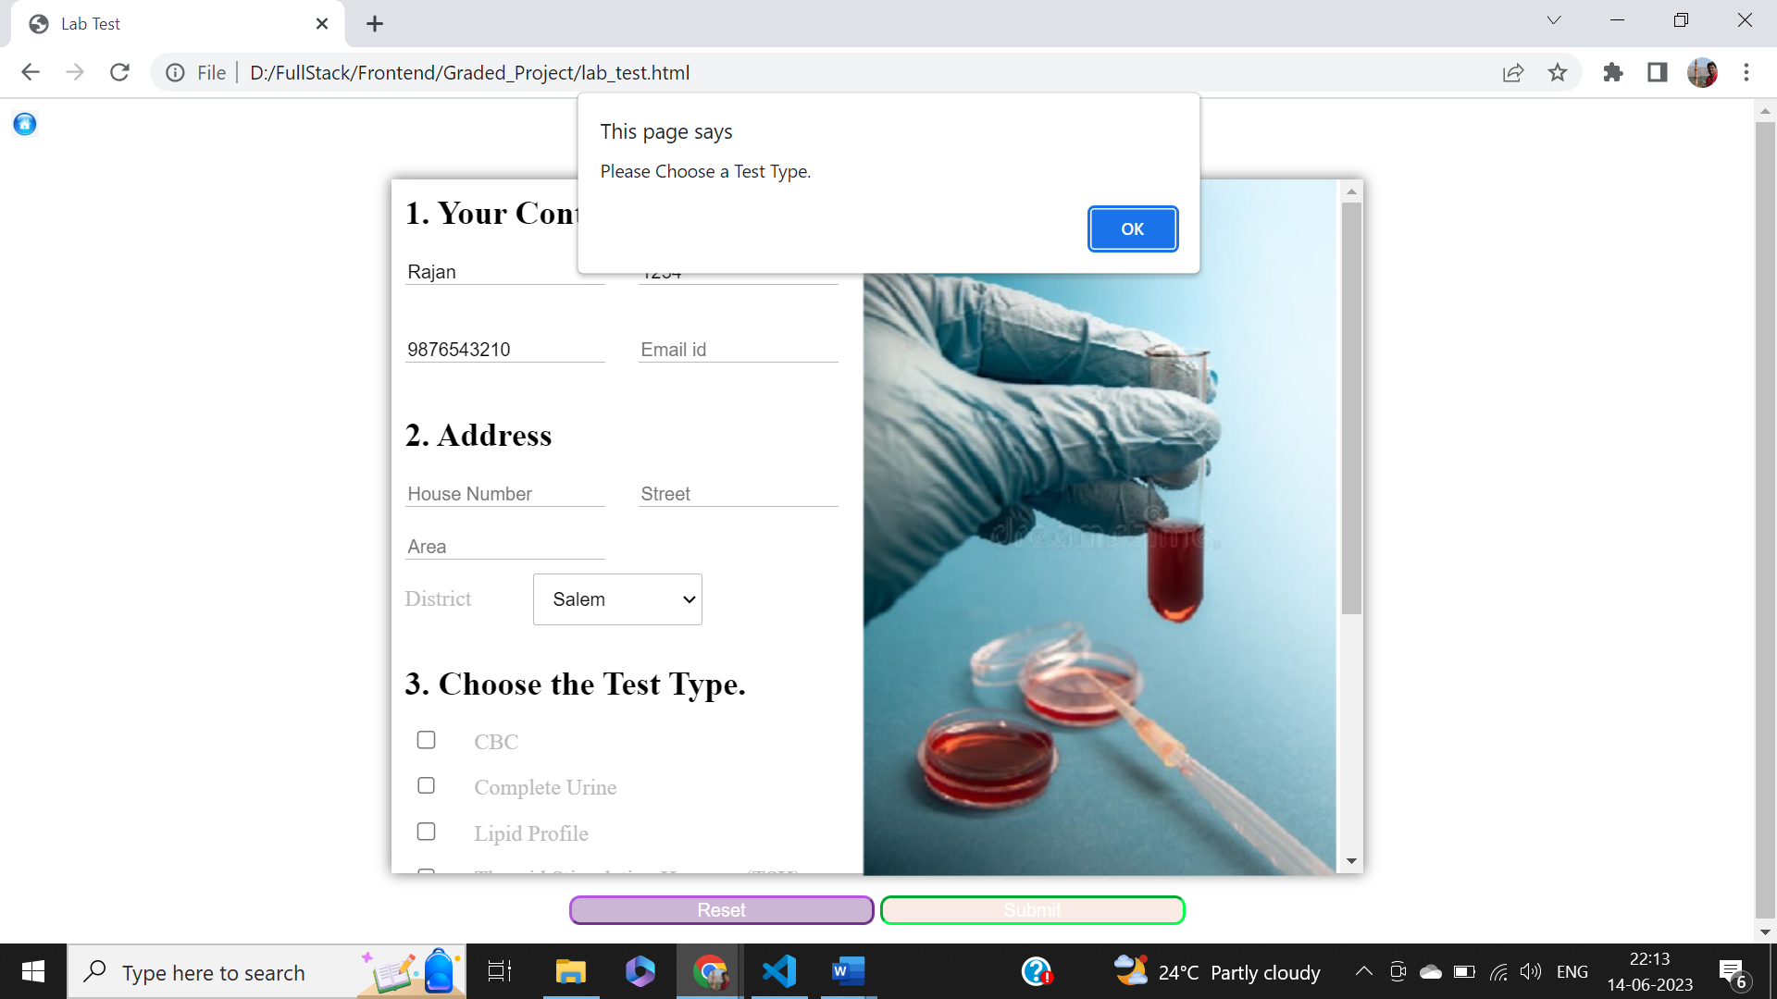

## System Alerts if the Date and Time is not selected: -

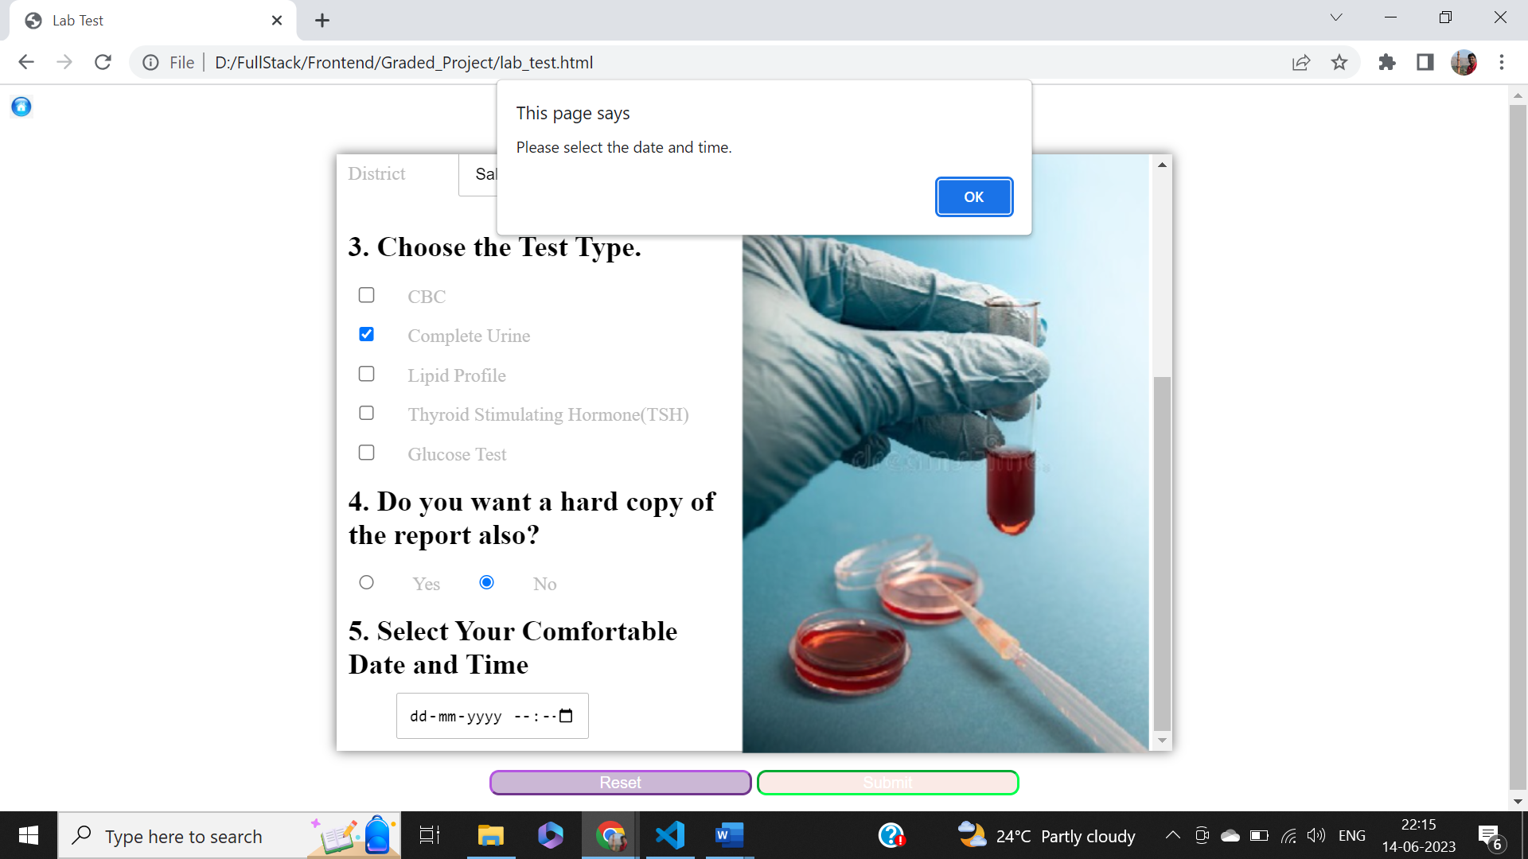

## System Alerts if the time is less than 2 hours from now: -

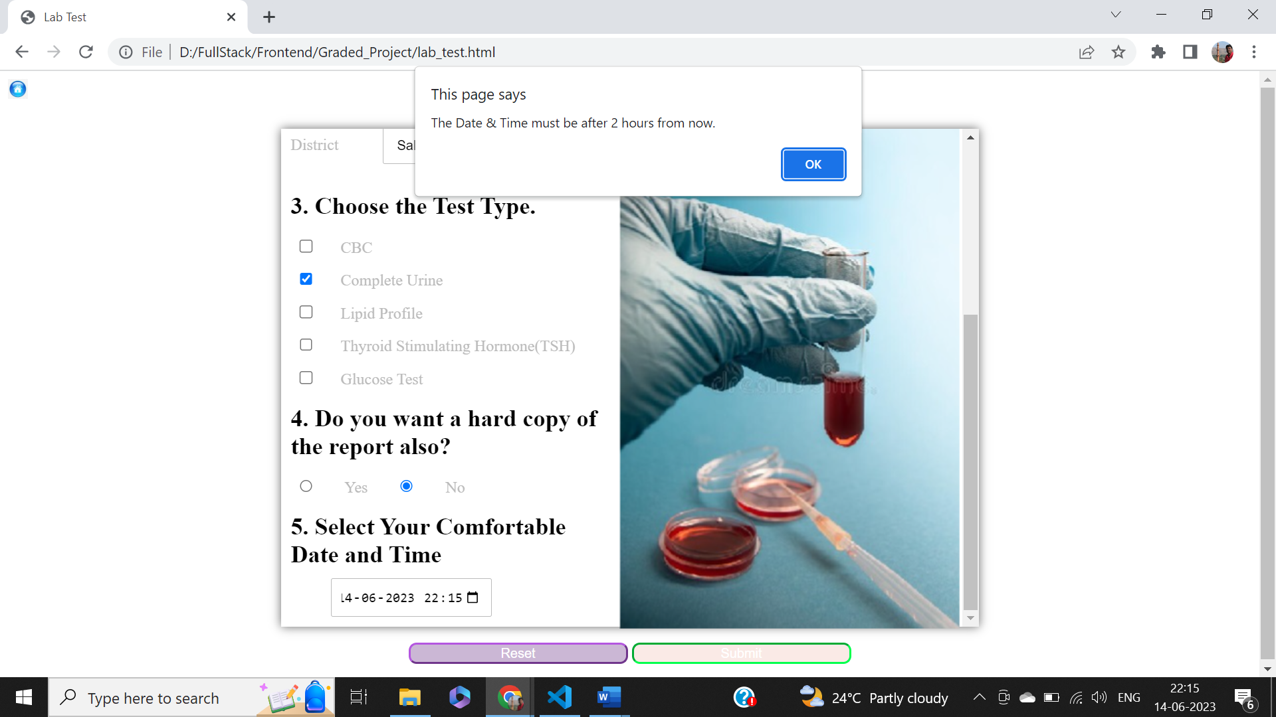

## Success Alert Message: -

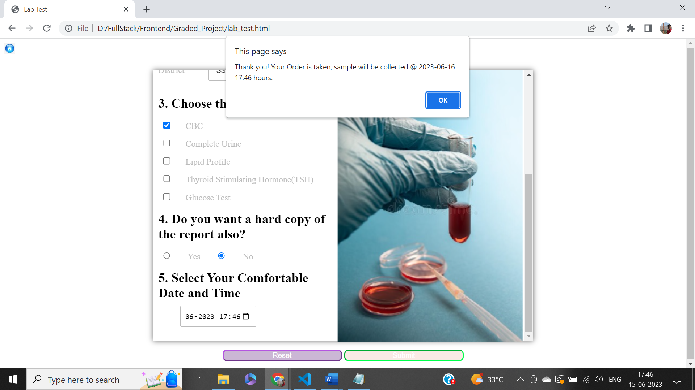

## Mandatory Field Alerts: -

### Screen 1 (Full Name): -

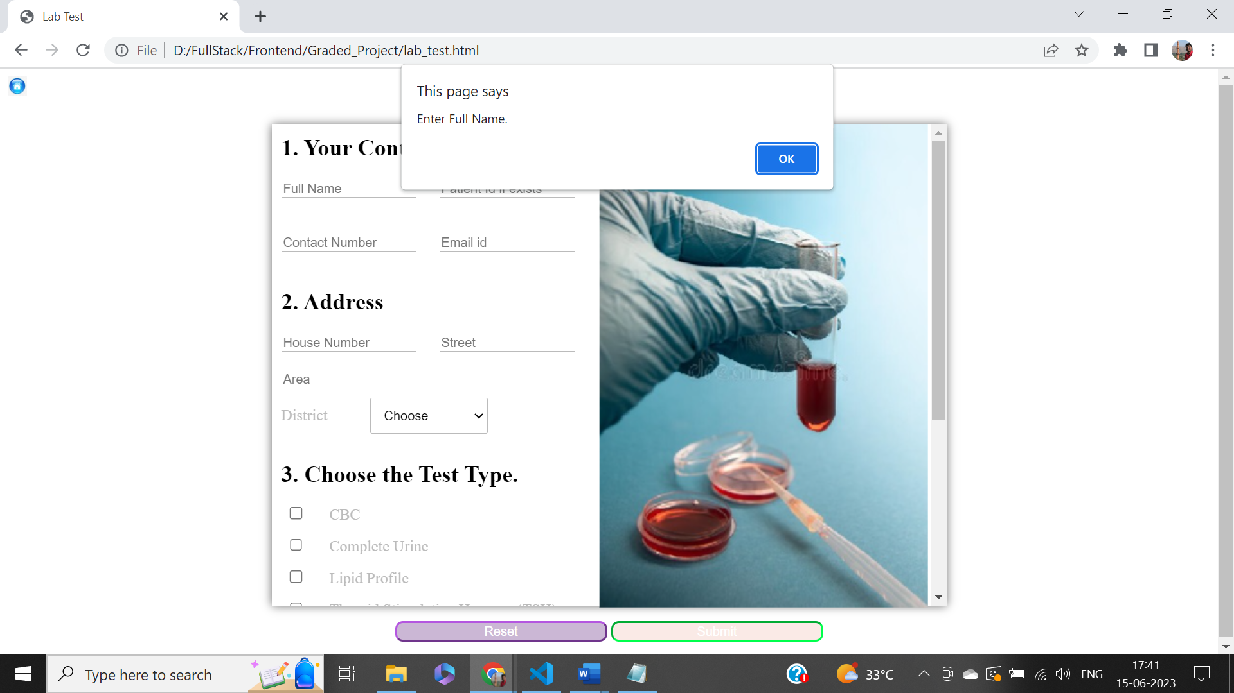

### Screen 2 (Contact Number): -

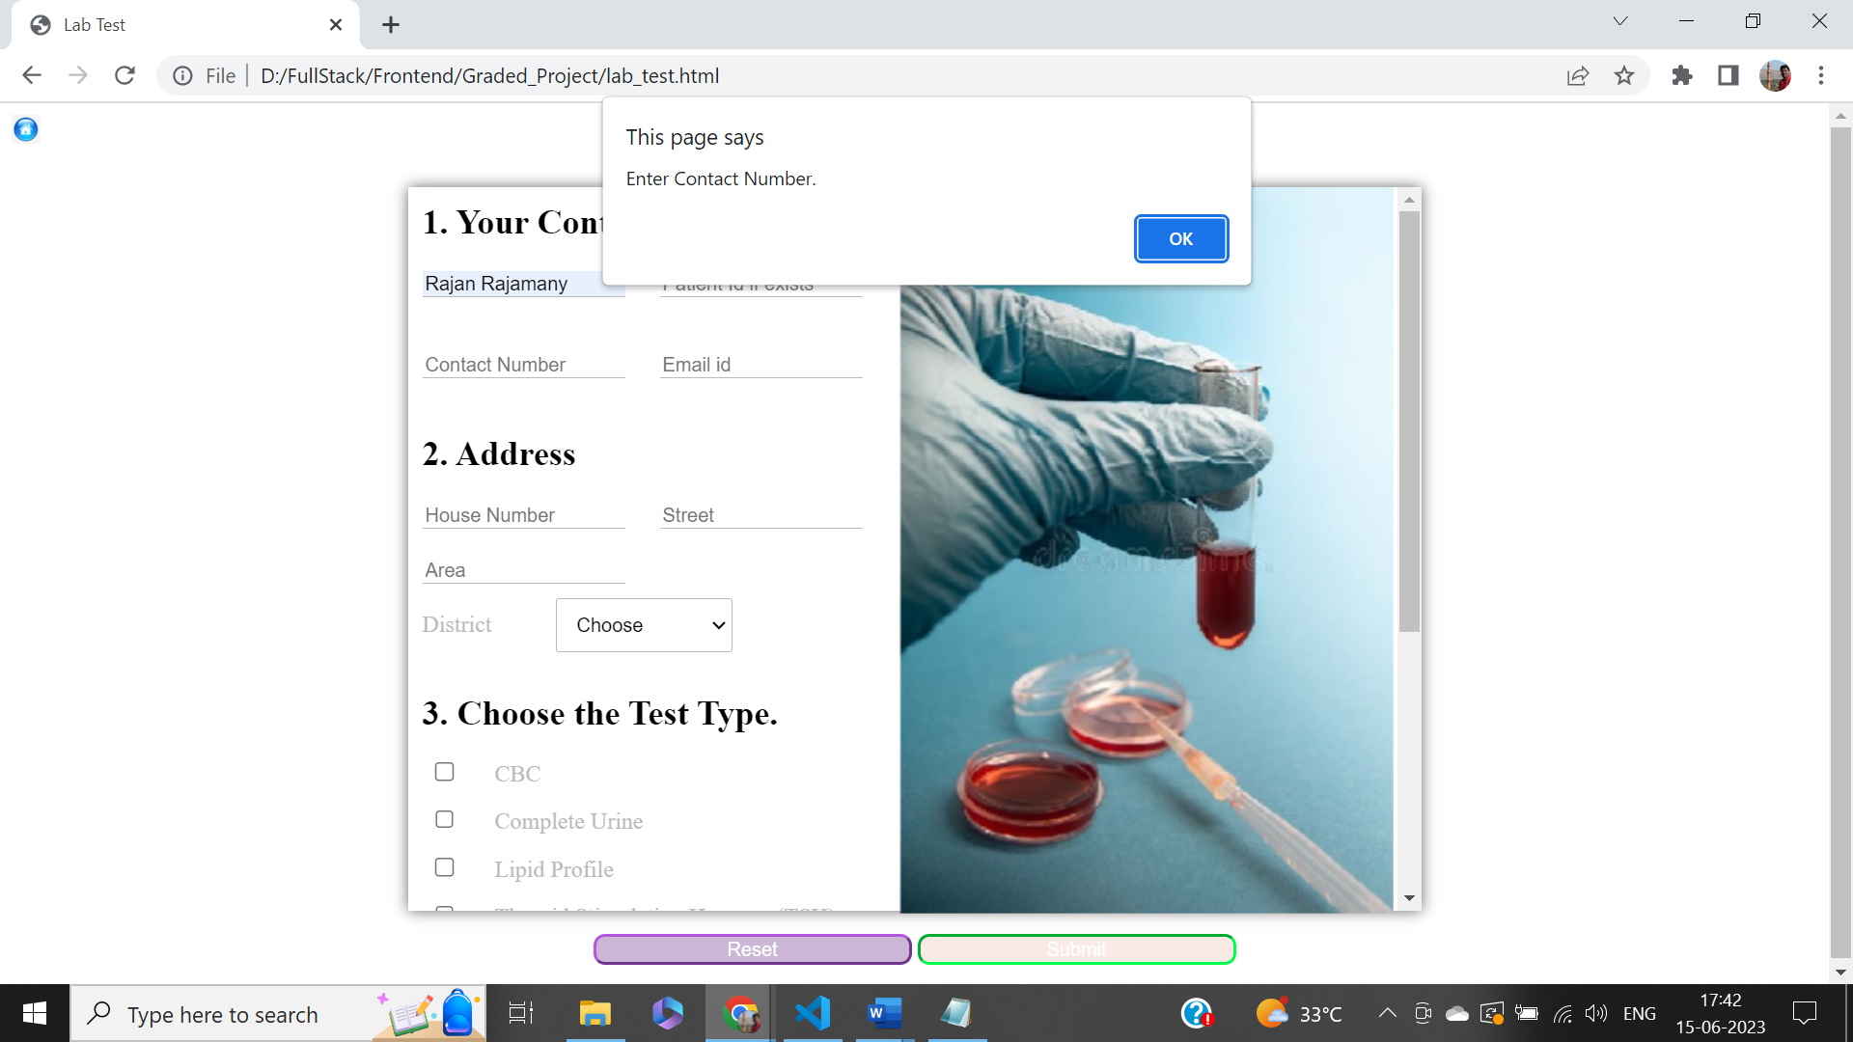

### Screen 3 (Email Id): -

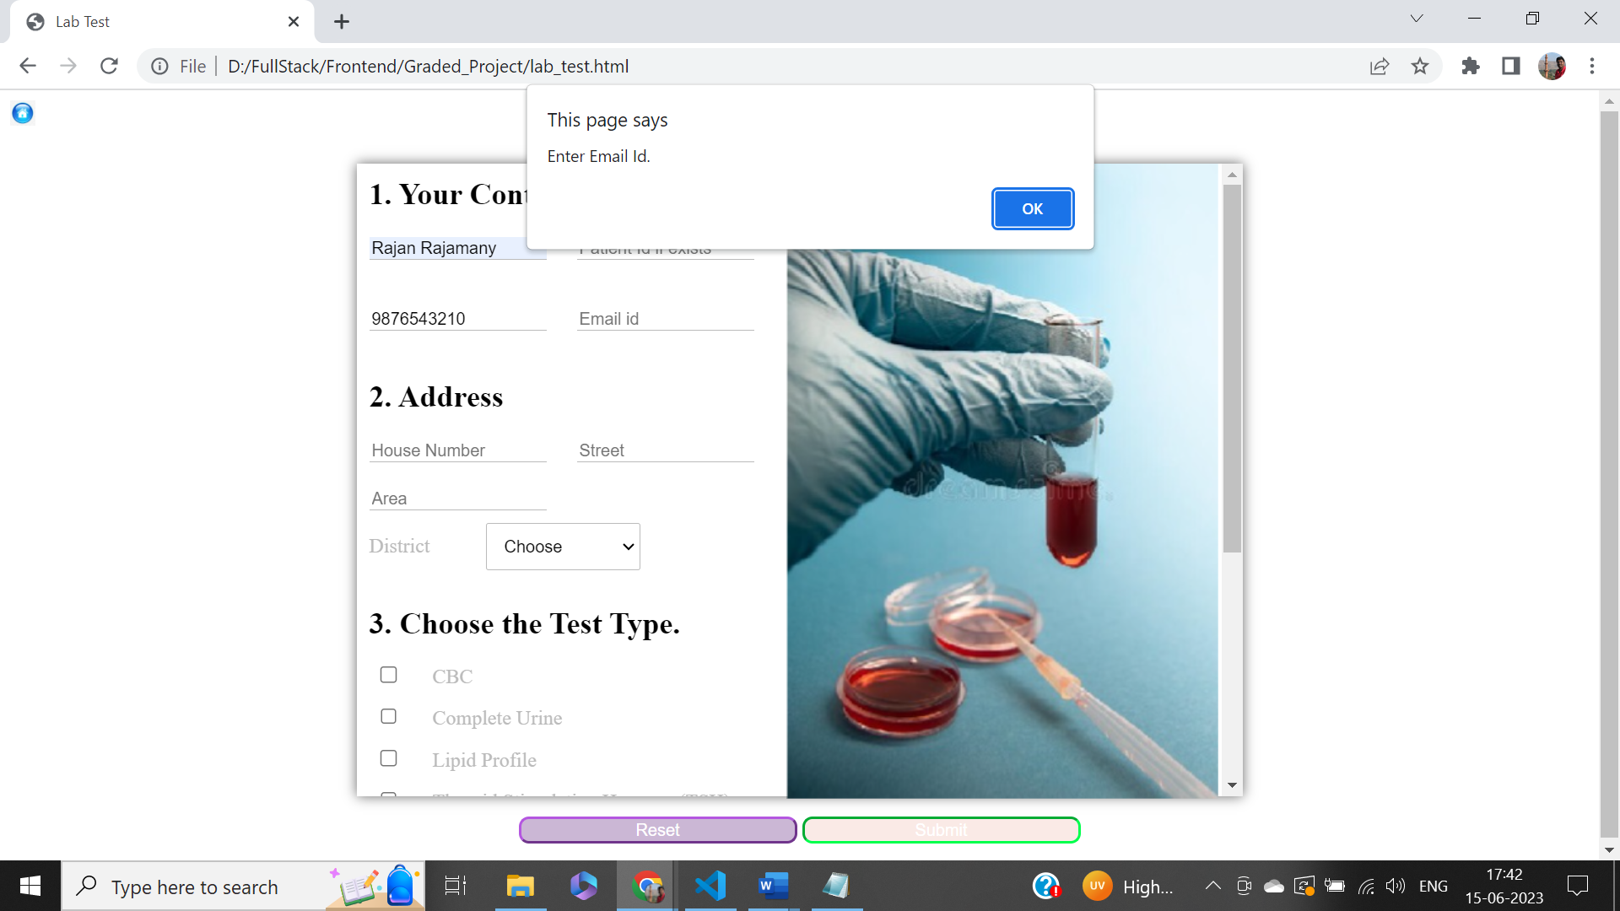

### Screen 4 (House No.): -

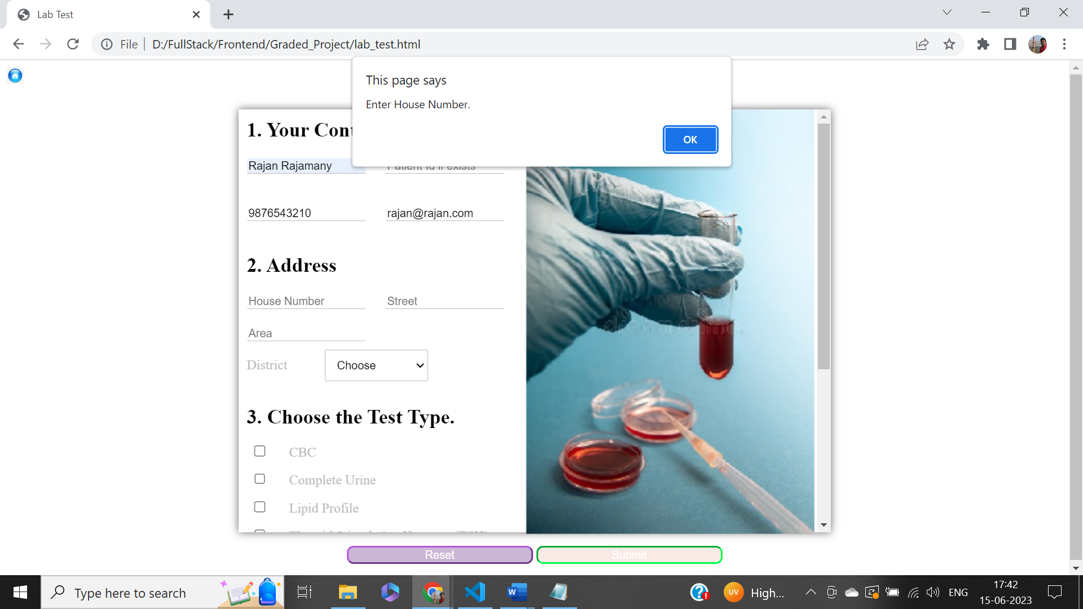

### Screen 5 (Street): -

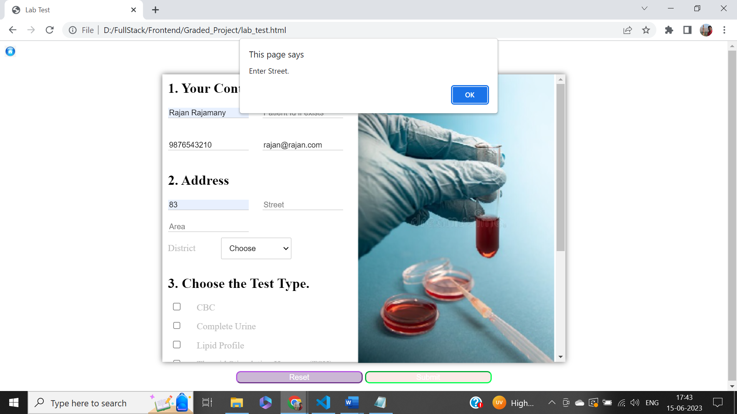

### Screen 6 (Area): -

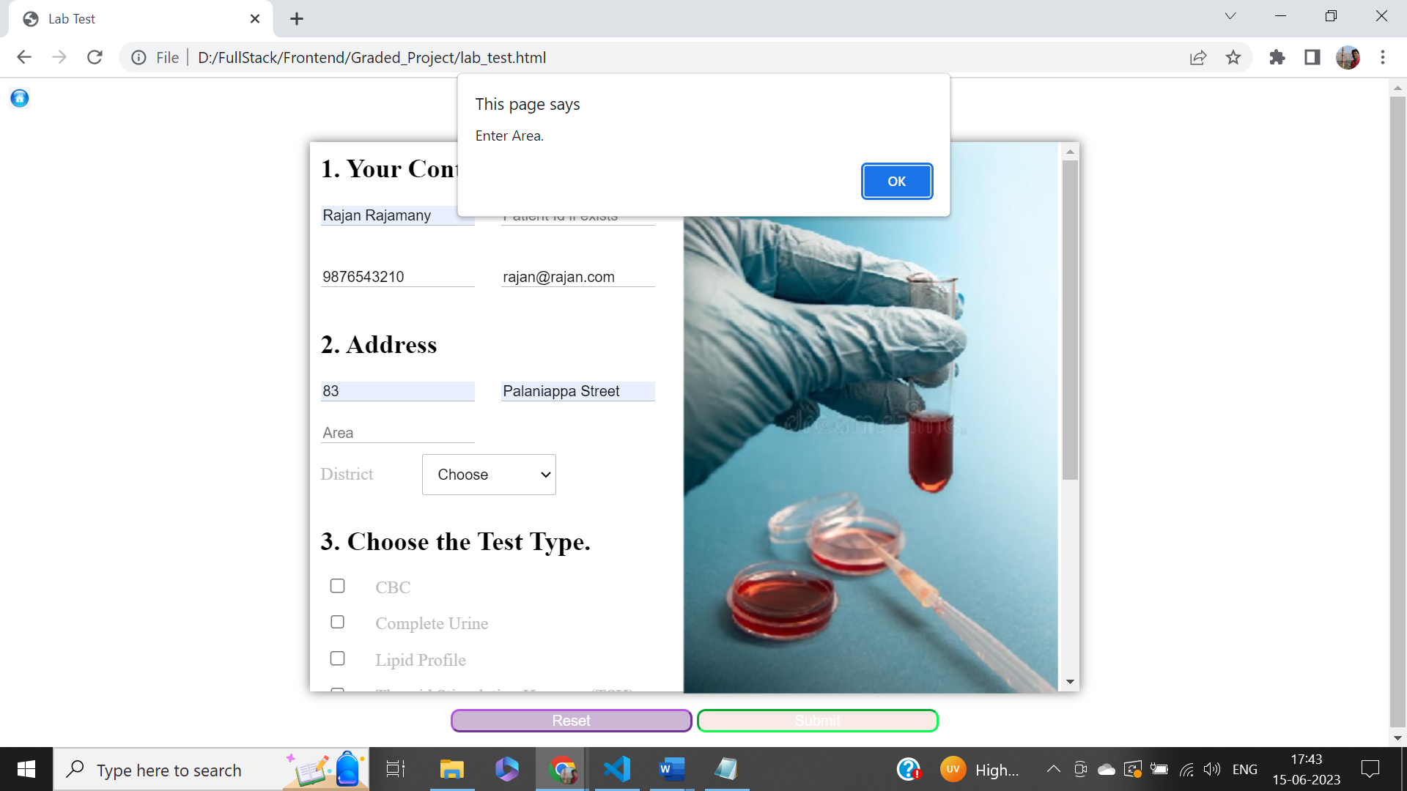

### Screen 7 (District): -

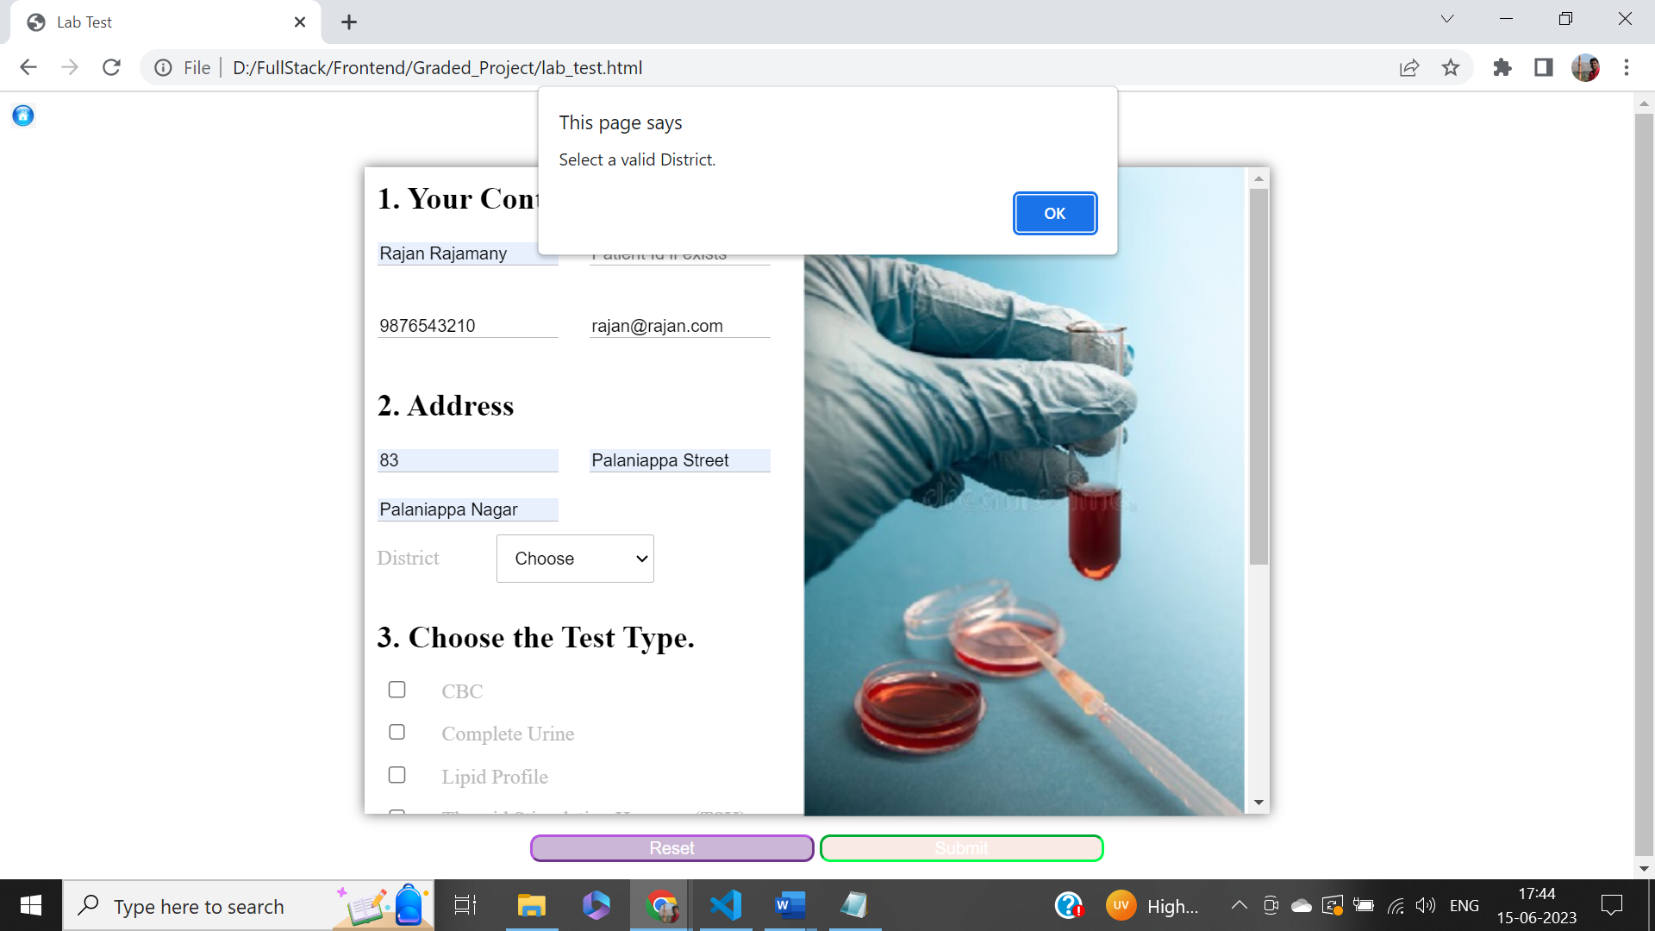

### Screen 8 (Test Type): -

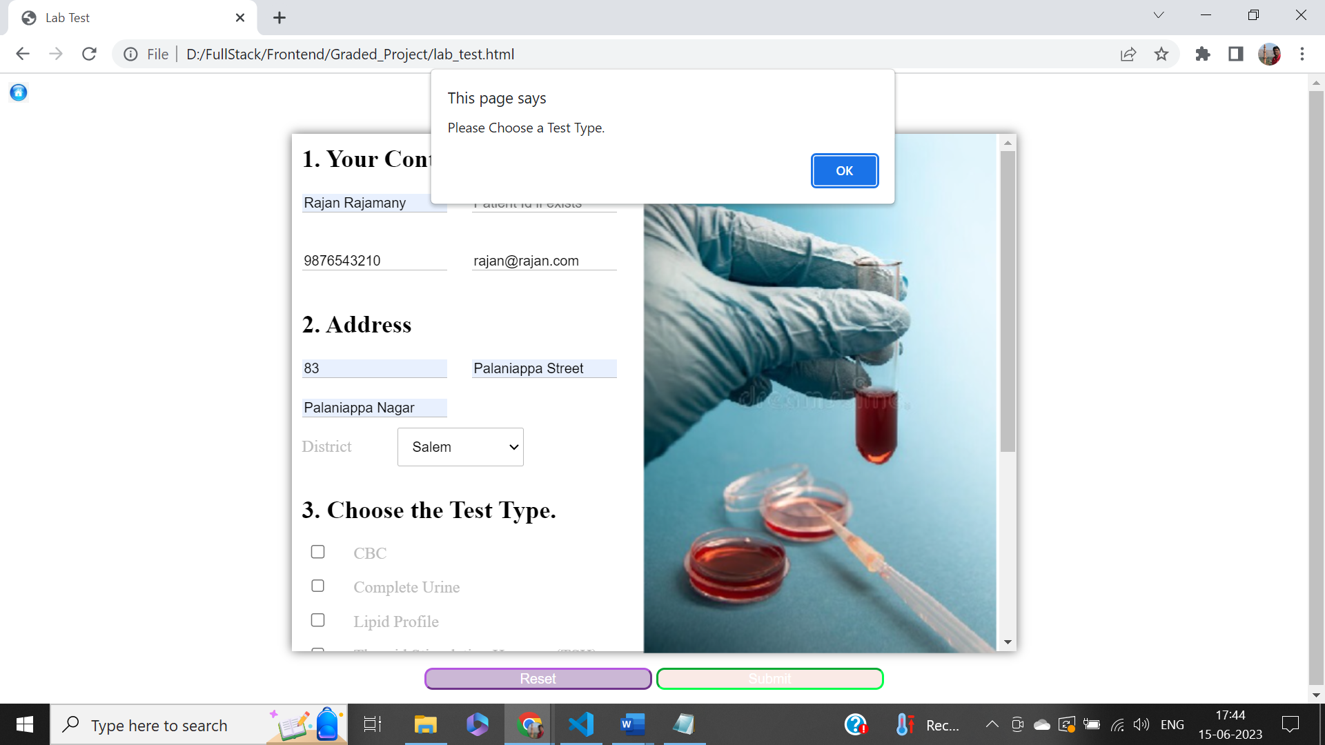

### Screen 9 (Date & Time): -

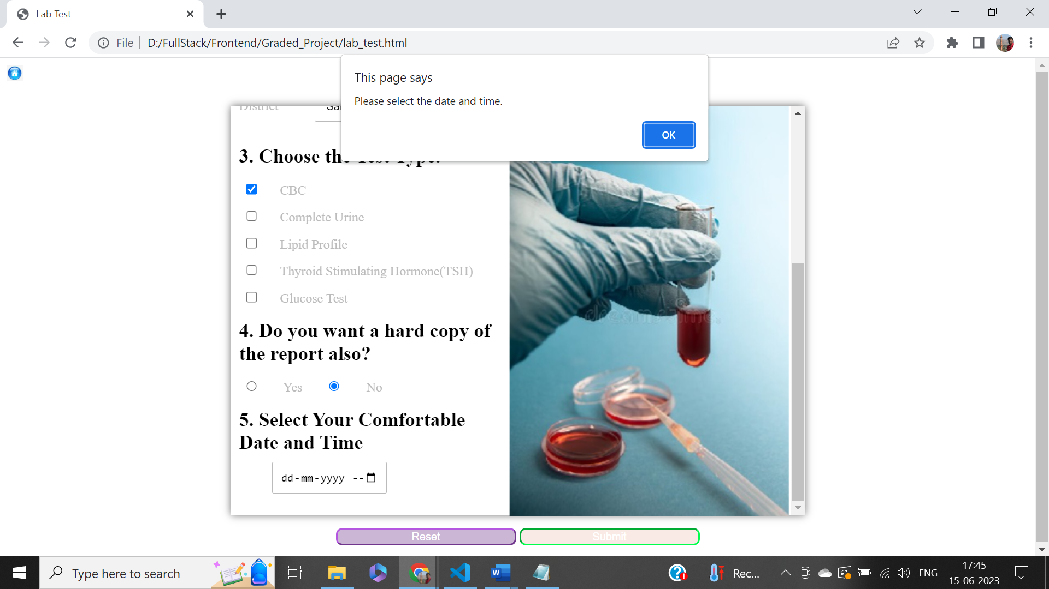

### Screen 10 (Time to be 2 hours from now): -

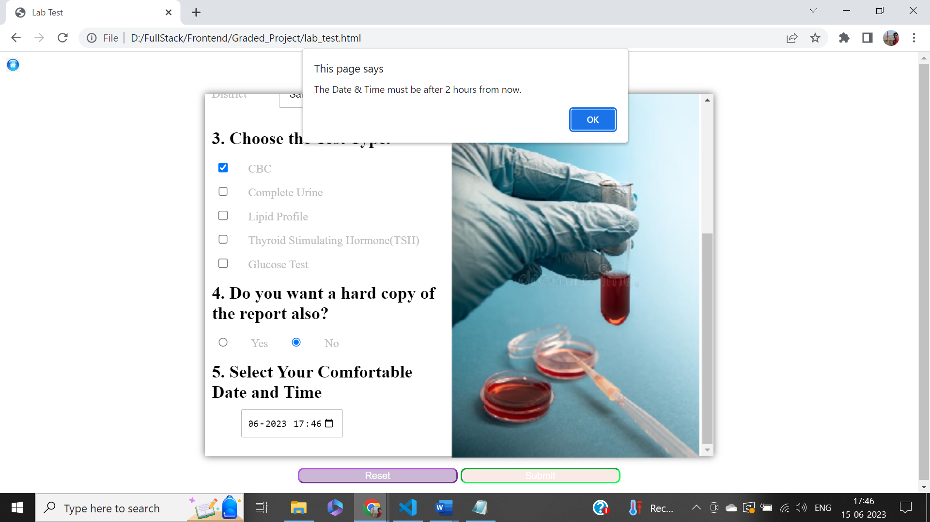

### Screen 11 (Success): -

